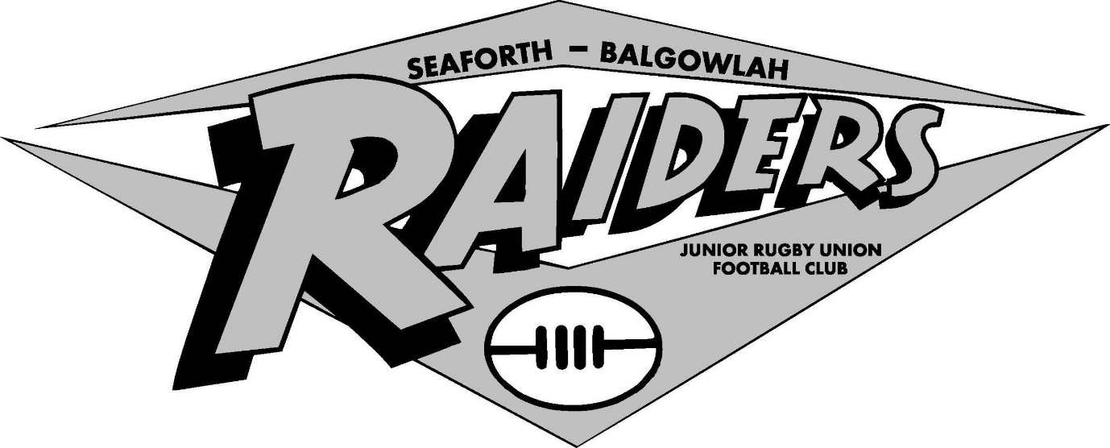

Purpose: In preparation for the Raiders Rugby Club to return to training we seek the approval of the Northern Beaches Council to provide clearance for use of Bantry Reserve as well as provision of lighting codes.
Background:
In line with the current NSW Government Health regulations and the Sydney Junior Rugby Union, we have conducted a risk assessment on our environment. The results of the risk assessment were;
- Implement notification procedures for all club participants driven by a positive COVID-19 test result for a player, club member or official.
- All equipment to be cleaned and in some cases protected and to remain in storage including but not limited to;
  - Balls (cleaned for use and cleaned prior to and after each use)
  - Cones ((cleaned for use and cleaned prior to and after each use)
  - Ropes (cleaned and put in storage)
  - Tackle bags (cleaned and put in storage)
  - Tackle shields (cleaned and put in storage)
  - Fridges (cleaned and put in storage)
  - Storage boxed (cleaned and put in storage)
  - Merchandise (cleaned and put in storage)
  - Water bottles (cleaned and put in storage)
  - Hand sanitiser stations to be made available during allocated times

- Canteen facilities will not be used until restrictions ease from 1 July with provision of hand sanitiser and signage.
- Due to Bantry Reserve being a public facility we will seek support from Council to assist with the cleaning of the public toilets more regularly.
Education & Training
- Raiders Rugby Club has appointed a COVID-19 Manager. Our COVID-19 Manager will be James Akhurst.
- All players (where appropriate), coaches, managers and officials are encouraged to download the COVIDSafe App and have their phone at training.
- All individual gear is to be kept in their own bag and must be taken to the side of the field and placed in dedicated areas with their phone inside.
- Any person showing signs and symptoms of Covid-19 (upper respiratory symptoms of fever, sore throat, cough, shortness of breath, chills and/or night sweats) must not attend training until undergoing a Covid-19 nasal swab test and receiving a subsequent negative result.
- Additional education will be provided to club members including but not limited to;
  - No drink bottles will be provided by the club. Each participant will be required to bring their own and are not permitted to share
  - For each session, the coach, manager or COVID19 representative will maintain a log of all people attending training. Players will be required to notify the coaching group of their attendance prior to training so that groups are prepared in advance. Players CAN NOT just show up to training. Raiders will aim to use TeamStuff as an online register of training attendance.
  - All players coaches, managers and officials MUST be registered with Rugby Australia and must have the minimum Smart Rugby qualification.
  - No hugging or shaking of hands or any physical contact.
  - Parents are responsible for their child at training, and where possible just one parent should attend Bantry Reserve to help reduce overall attendee numbers.
  - At all times, enforce through verbal communication and additional literacy the required behaviours (e.g. regular and thorough handwashing, covering mouth and nose with a tissue or sleeve during coughing/sneezing)
  - Work with Council and other rugby clubs in the Northern Beaches to procure relevant education materials using suggested materials available such as
    - Good hygiene for coronavirus
    - Handwashing guidance
    - Keep that cough under cover
    - Self-isolation for coronavirus
    - Advice for people at risk with coronavirus
    - Other coronavirus resources

- Training will follow the Australian Institute of Sports “get in and get out’ strategy.
- All spectators are to comply with the 1.5m distancing law.
- Transition to full contact training from 1 July will occur to comply with NSW Health and Sydney Junior Rugby Union guidelines.
Request for Season Access Extension
Raiders Rugby has been informed Sydney Junior Rugby Union are planning a season running until late September 2020, followed by a Spring 7s Rugby competition.
Raiders Rugby requests Northern Beaches Council to approve ground allocation dedicated to Raiders for the period 10 Jun 2020 to 6 December 2020.

Agreed/Not Agreed
Northern Beaches Council

